COMP 361/5611 – Elementary Numerical Methods

Assignment 1 Zisen Ling 40020293

Problem 1.

1. For the first arithmetic, like the question mentions, the sum is behavior as diverge as N tends to infinity. In other words, the sum can be arbitrarily large by taking N sufficiently large. Also, the bigger N is, the smaller the result is. However, the resource for the computer is limited, we never have a chance to have Infinite places after the decimal point. Therefore, whether it is single or double, the maximum will hold at a certain value. For example, if there is a value hold only two places after 0, let us say 0.78, if we add 0.001, it is still 0.78. For this problem, we can find that the value will be hold at a certain place.

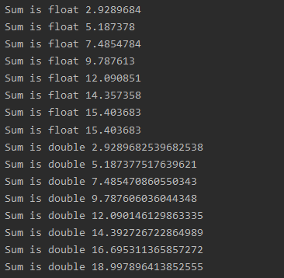

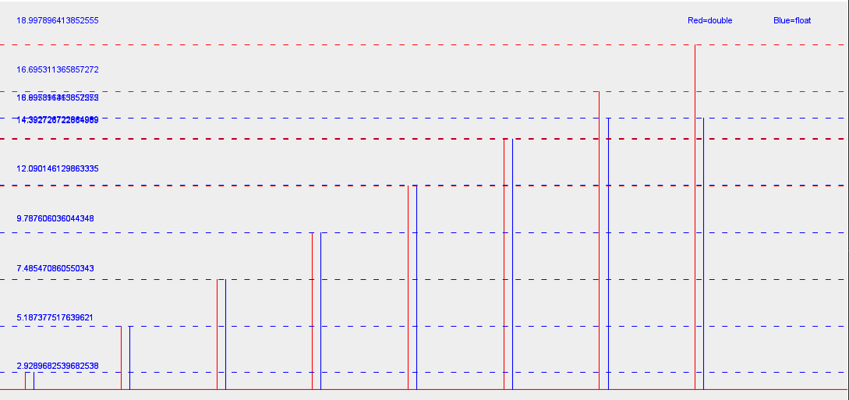

1. For the second arithmetic, like the question mentions, the sum is behavior as converge as N tends to infinity. It is geometric Series, and |r| < 1, therefore, this arithmetic is converging to 1/(1-r), that is, 1/2.

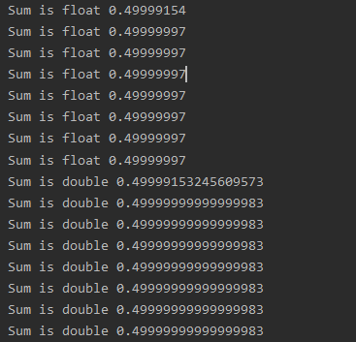

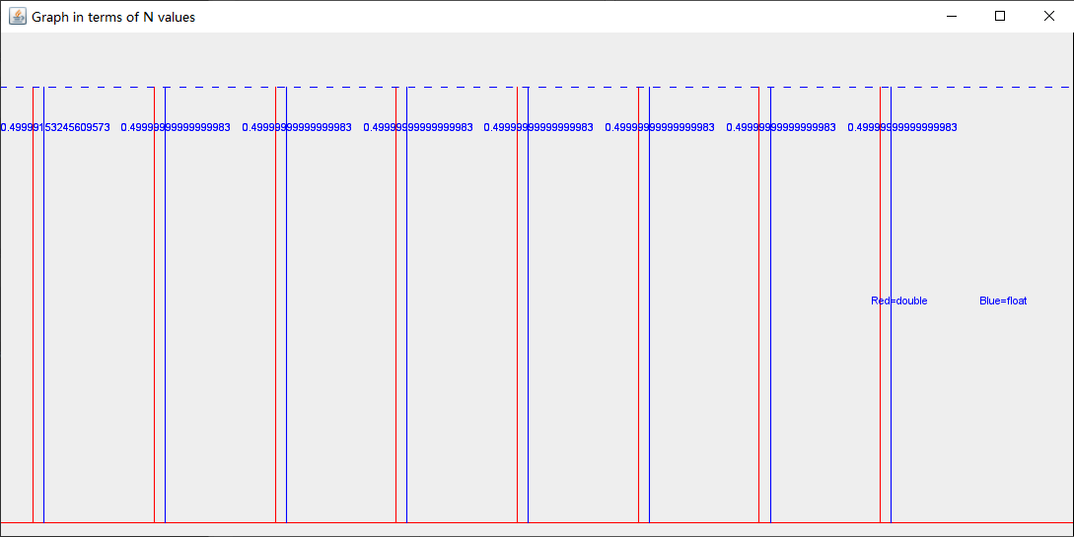

Problem 2.

1. For , N = 20.

|  |  |
| --- | --- |
|  |  |

No, it does not depend on x0. From the textbook, I found out that method is called ‘fixed point iteration’, if it converges to a point x, then one can prove that the obtained x is fixed point of function. To prove convergence, find α = 5^1/3 (where x =2x^3/3x^2), which is around 1.70997… plug back to f’(α), found 0<1, so it is converge.

|  |  |
| --- | --- |
|  | when x0 equals 50.0. |

|  |  |
| --- | --- |
|  |  |
|  | To prove convergence, find α = -1/19 (where x =0.95x(1-x)).Plugging back to f’(α), found 4.39894..>1, so it is diverging. |
|  |  |
|  | To prove convergence, find α = 11/31 (where x =1.55x(1-x)). Plugging back to f’(α), found 0.45<1, so it is converge. |
|  |  |
|  | To prove convergence, find α = 1/2 (where x =2x(1-x)). Plugging back to f’(α), found 0<1, so it is converge. |
|  |  |
|  | To prove convergence, find α = 13/18 (where x =3.6x(1-x)). Plugging back to f’(α), found |-1.6|>1, so it is diverge |
|  |  |
|  | To prove convergence, find α = 149/199 (where x =3.98x(1-x)). Plugging back to f’(α), found |-1.98|>1, so it is diverge |

Problem 3.

The behavior of the error decreases as the M increase or h decrease.

By the observation, Simpson’s Rule has much more efficiency than the Midpoint Rule.

For p:

This is what I observed:

|  |  |  |  |  |
| --- | --- | --- | --- | --- |
| Same numbers after “.” | mid | | simp | |
| 1 | 8 | 2^3 | 2 | 2^1 |
| 2 | 16 | 2^4 | 4 | 2^2 |
| 3 | 64 | 2^6 | 8 | 2^3 |
| 4 | 512 | 2^9 | 16 | 2^4 |
| 5 | 512 | 2^9 | 64 | 2^6 |
| 6 | 2048 | 2^11 | 64 | 2^6 |
| 7 | 8192 | 2^13 | 64 | 2^6 |
| 8 | 32768 | 2^15 | 128 | 2^7 |

Therefore, the relationship between two method：

Midpoint ≈ (simpson’s)^(2^2+1)

It is easy to observe that as the M gets infinity large, the result will be the same as integral.

**Find the n of sin(pi*x) where error bounds <= 10^-7**

**First compute K, f(x)’’ = -pi^2sin(pi*x) where K = 9.87**

**Then add it to** 

**Find 9.87(b-a)^3/24n^2 < 10^-7, where n is around 2028**

**Then the smallest value of M is 2028,**

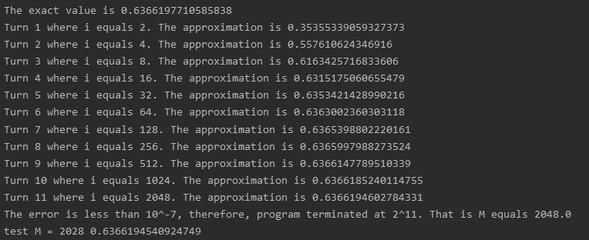

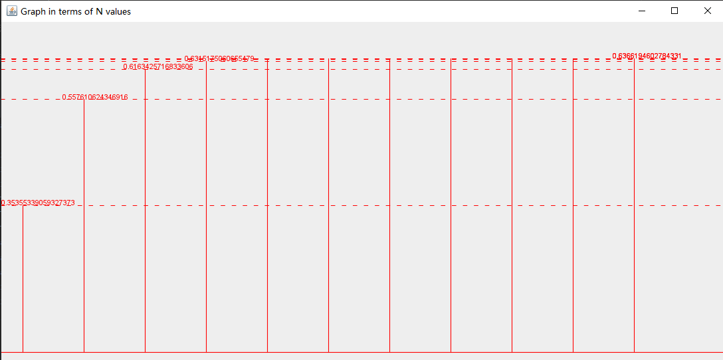

**Find the n of sin(pi*x) where error bounds <= 10^-7**

**First compute K, f(4)(x) = pi^4*sin(pi*x) where K = 97.409**

**Then add it to **

**Find 97.409(b-a)^5/180n^4 < 10^-7, where n is around 48**

**Then the smallest value of M is 48,**



